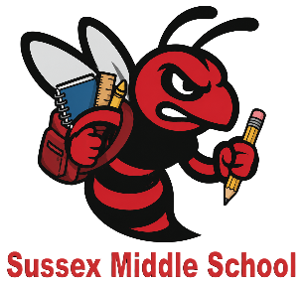
SUSSEX MIDDLE SCHOOL

GRADE 6 (ENGLISH)
STUDENT SUPPLY LIST FOR 2026-2027

Please purchase enough supplies during the summer sales to last the year. We often see students running out of materials after March Break and materials are often more expensive at that time. The amounts listed below should be enough to get them through the year.

2 - one-inch binders – different colours
pencil sharpener (a good one)
pencil case
2 glue sticks
ruler
Gym
- gym shorts or sweatpants and a t-shirt
- gym sneakers

Music/Tech
- headphones or earbuds

Art
- colouring medium – student’s choice (crayons, markers or pencil crayons)
15 duotangs
2 boxes of Kleenex
5 packages of HB pencils
scissors
2 black sharpies
2 white erasers
markers
pencil crayons
1 pack of looseleaf
1 package of white photocopy paper
2 highlighters - different colours
1 package of Hilroy scribblers (4pk)
Student Fee - $25.00

We hope you have a safe and happy summer. See you in September!
Grade 6 English Team

